LiTian’s Assignment 6

ChatApp

**Introduction**

Define the logic for waiting for incoming messages on a separate background thread.

Use service displays messages received and allows messages to be sent (so the app is now like a two-way radio).

Define a background thread, that waits for incoming messages without blocking on the main UI thread.

Define the service as one that the main chat activity binds to when it starts up.

Update the UI with the new message received

**Pre-requisites**

* Nexus 5X AVD
* Android 5.1(Lollipop)

telnet localhost 5554

auth <token>

redir add udp:6667:6666

quit

telnet localhost 5556

auth <token>

redir add udp:6668:6666

quit

When you run these two devices, say with the first device named Server and the second

device named Client, specify 6668 as the target port for the former and 6667 as the target

port for the latter.

**Screenshots**

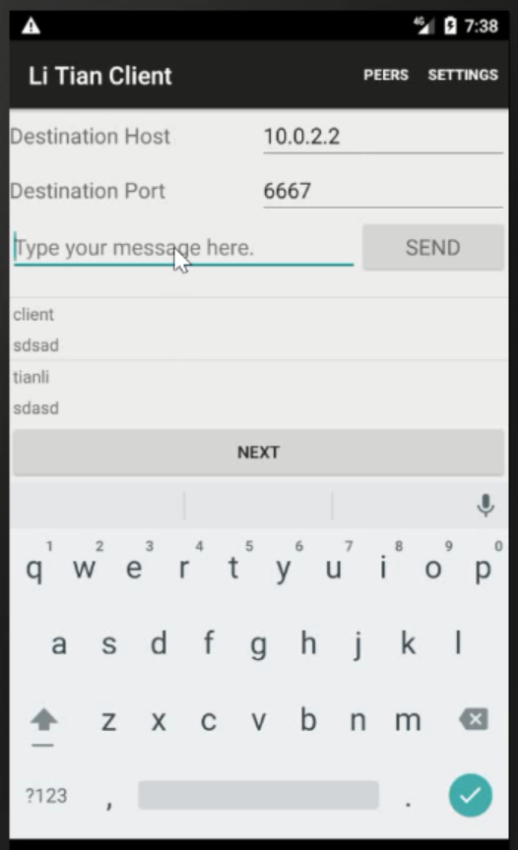 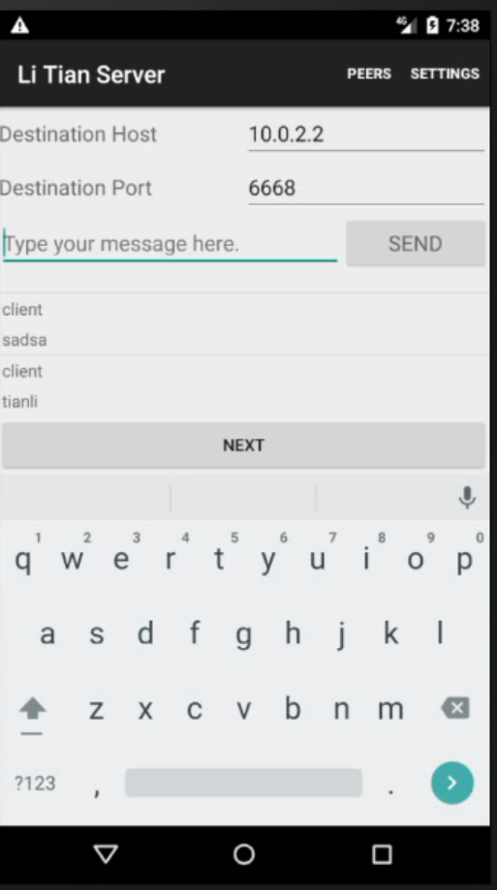

**Getting Started**

This sample uses the Gradle build system. To build this project, use the "gradlew build" command or use "Import Project" in Android Studio.